**Professor Xin Chen, Biometrics, Fall 2015**

**Assignment: Iris Segmentation**

1. A toy example of edge pixels of an iris image. Please detect the circle boundary with r = 3 pixels using Hough Transform i.e. show the Hough space voting process and plot the fitted circle on the original edge image.

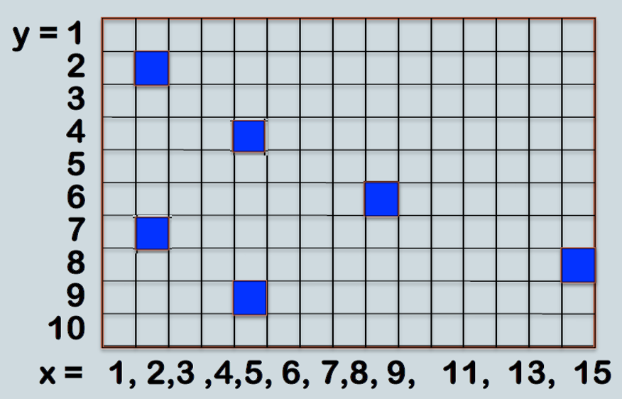

Answer:

Voting steps

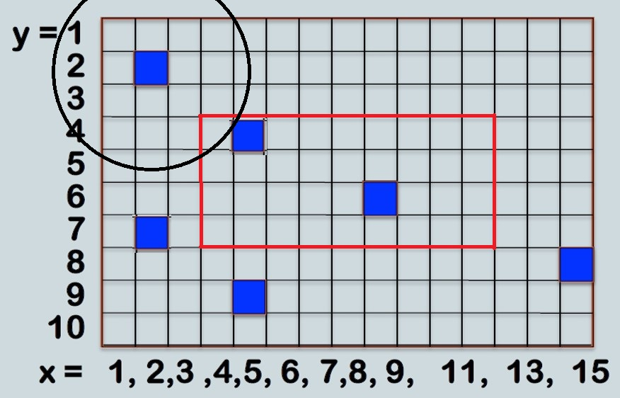

1st vote

|  |  |  |  |  |  |  |  |  |  |
| --- | --- | --- | --- | --- | --- | --- | --- | --- | --- |
| **4** | 1 |  |  |  |  |  |  |  |  |
| **5** |  |  |  |  |  |  |  |  |  |
| **6** |  |  |  |  |  |  |  |  |  |
| **7** |  |  |  |  |  |  |  |  |  |
|  | **4** | **5** | **6** | **7** | **8** | **9** | **10** | **11** | **12** |

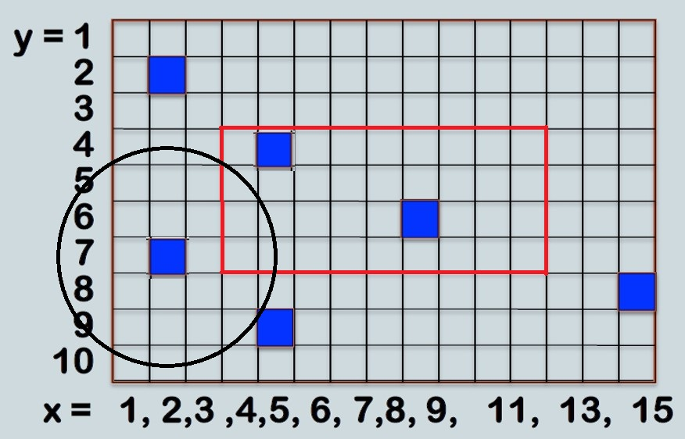

2nd vote

|  |  |  |  |  |  |  |  |  |  |
| --- | --- | --- | --- | --- | --- | --- | --- | --- | --- |
| **4** | 1 |  |  |  |  |  |  |  |  |
| **5** | 1 |  |  |  |  |  |  |  |  |
| **6** |  | 1 |  |  |  |  |  |  |  |
| **7** |  | 1 |  |  |  |  |  |  |  |
|  | **4** | **5** | **6** | **7** | **8** | **9** | **10** | **11** | **12** |

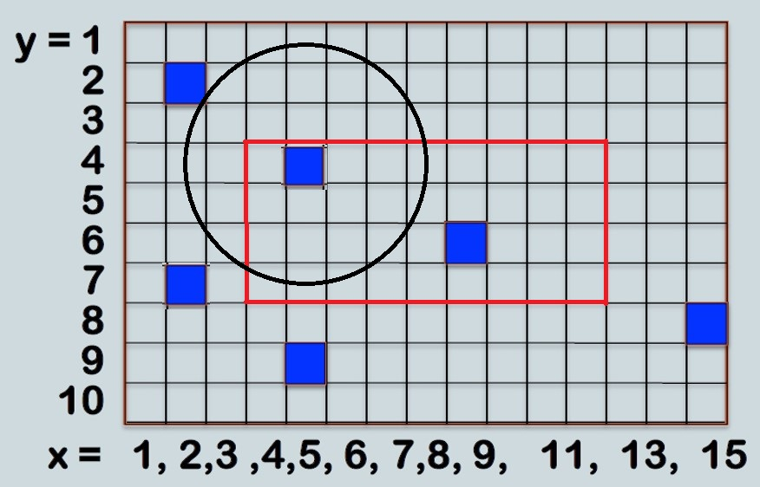

3rd vote

|  |  |  |  |  |  |  |  |  |  |
| --- | --- | --- | --- | --- | --- | --- | --- | --- | --- |
| **4** | 1 |  |  |  | 1 |  |  |  |  |
| **5** | 1 |  |  |  | 1 |  |  |  |  |
| **6** |  | 1 |  | 1 |  |  |  |  |  |
| **7** | 1 | 2 | 1 |  |  |  |  |  |  |
|  | **4** | **5** | **6** | **7** | **8** | **9** | **10** | **11** | **12** |

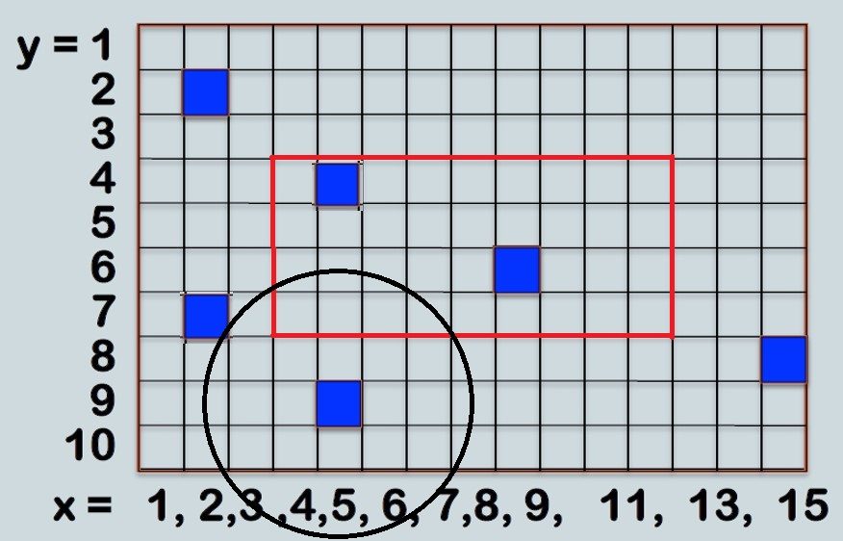

4th vote

|  |  |  |  |  |  |  |  |  |  |
| --- | --- | --- | --- | --- | --- | --- | --- | --- | --- |
| **4** | 1 |  |  |  | 1 |  |  |  |  |
| **5** | 1 |  |  |  | 1 |  |  |  |  |
| **6** | 1 | 2 | 1 | 1 |  |  |  |  |  |
| **7** | 1 | 2 | 1 | 1 |  |  |  |  |  |
|  | **4** | **5** | **6** | **7** | **8** | **9** | **10** | **11** | **12** |

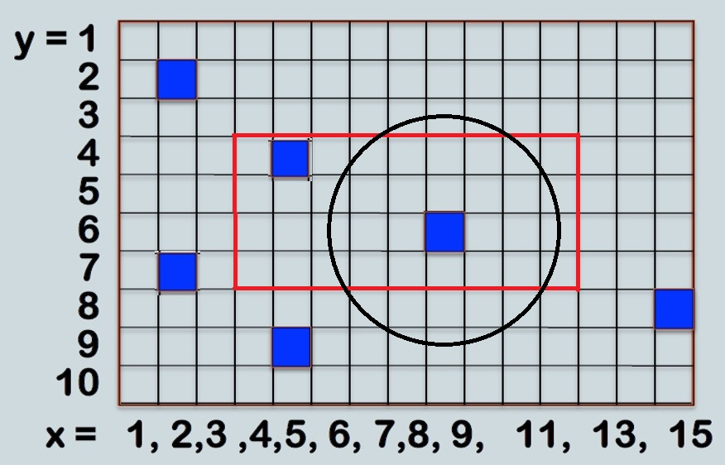

5th vote

|  |  |  |  |  |  |  |  |  |  |
| --- | --- | --- | --- | --- | --- | --- | --- | --- | --- |
| **4** | 1 |  |  | 1 | 1 |  |  | 1 |  |
| **5** | 1 |  | 1 |  | 1 |  |  |  | 1 |
| **6** | 1 | 2 | 2 | 1 |  |  |  |  | 1 |
| **7** | 1 | 2 | 2 | 1 |  |  |  |  | 1 |
|  | **4** | **5** | **6** | **7** | **8** | **9** | **10** | **11** | **12** |

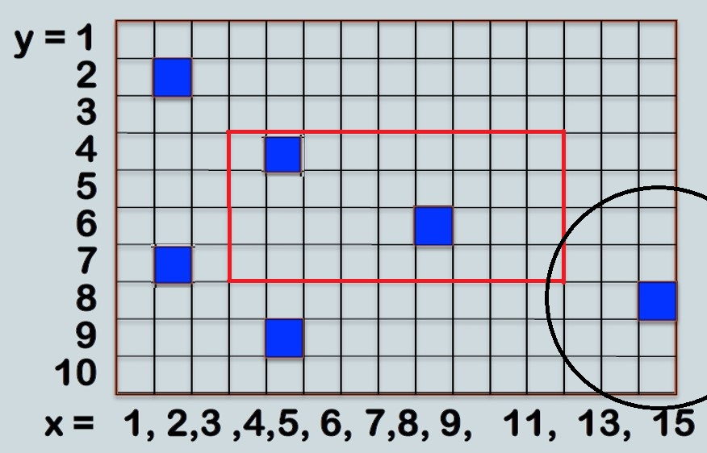

6th vote

|  |  |  |  |  |  |  |  |  |  |
| --- | --- | --- | --- | --- | --- | --- | --- | --- | --- |
| **4** | 1 |  |  | 1 | 1 |  |  | 1 |  |
| **5** | 1 |  | 1 |  | 1 |  |  |  | 1 |
| **6** | 1 | 2 | 2 | 1 |  |  |  |  | 1 |
| **7** | 1 | 2 | 2 | 1 |  |  |  |  | 2 |
|  | **4** | **5** | **6** | **7** | **8** | **9** | **10** | **11** | **12** |

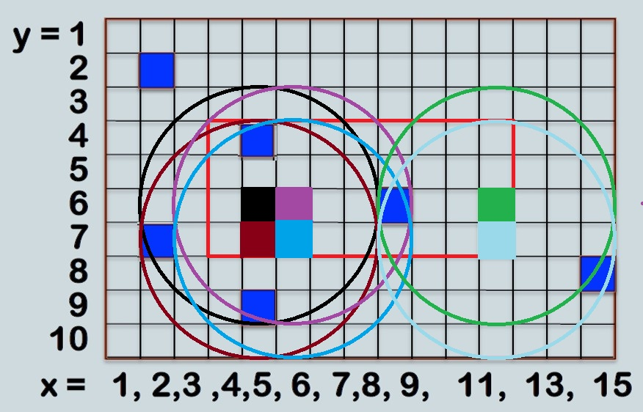

final result

1. Write a program to automatically extract iris from all the images attached using either hough transform or integro-differential operator. Please submit an executable and your result images showing the circular boundaries.